HackerRank Program 6
Link :- https://www.hackerrank.com/challenges/for-loop-in-c/problem
Successful Submission 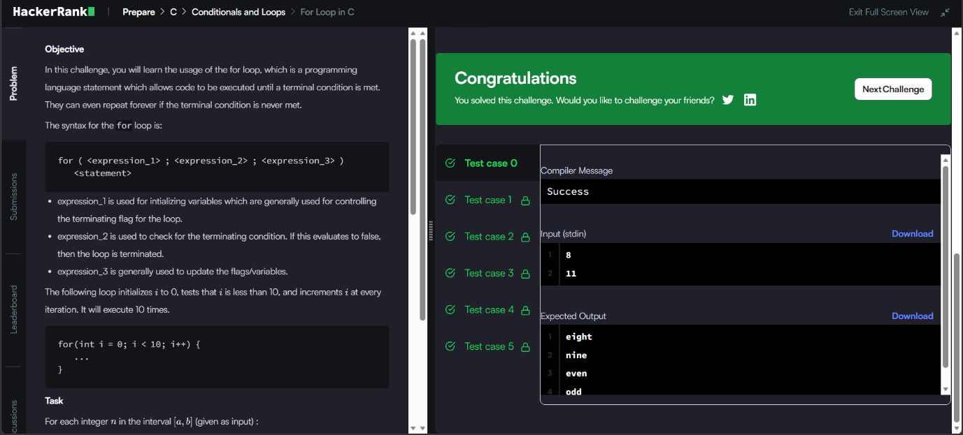
Source Code


